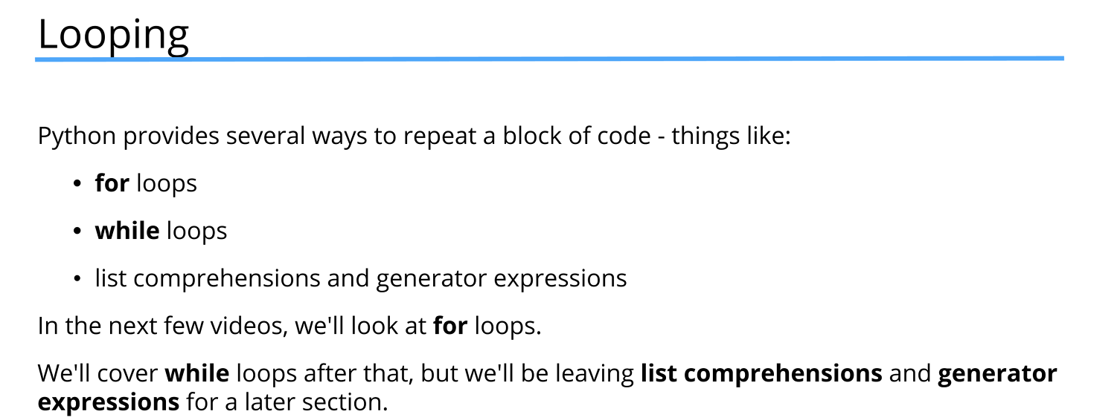
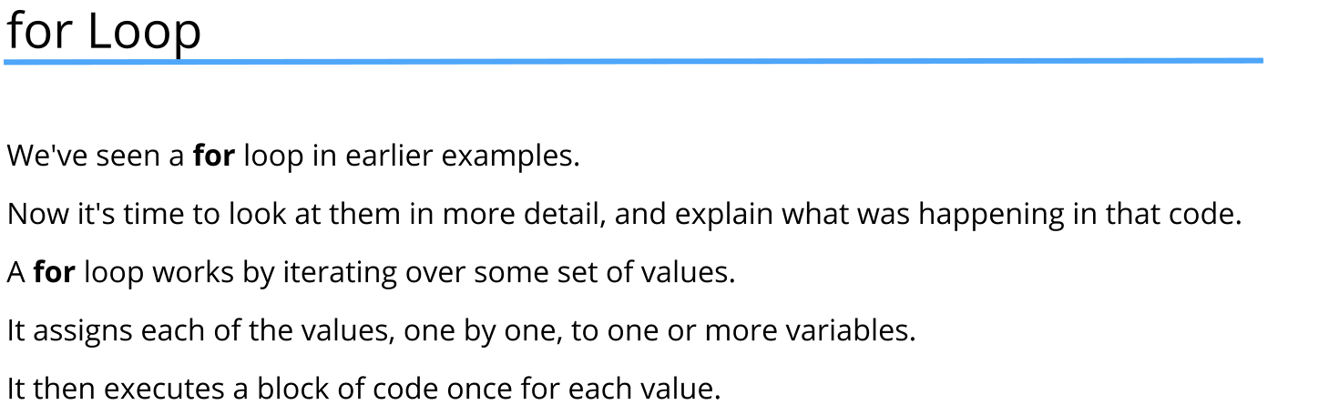
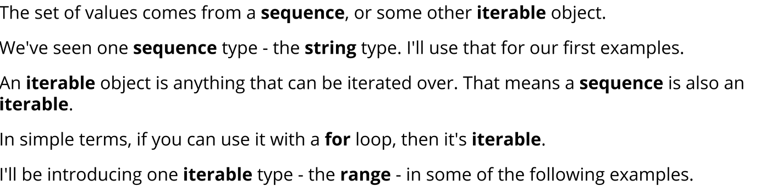
parrot = "Norwegian Blue"

#for loop can be used to iterate over every iterable object
#a iterable object is an object that can return its elements one at a time
#for loop begins with the keyword 'for' followed by a variable name that will
#hold each element of the iterable object during each iteration
#then the keyword 'in' followed by the iterable object to be looped over
for character in parrot:
print(character)

numbers = "9,223;372:036 854,775;807"
separators = ""

for char in numbers:
#isnumeric() method returns True if the string is a number
if not char.isnumeric():
separators += char

print(separators)

numbers = input("Please enter series of numbers with any separators you like: ")

separators = ""

for char in numbers:
if not char.isnumeric():
separators += char

print(separators)

values = [int(char) for char in numbers if char.isnumeric()]

#sum function adds all the items in an iterable and returns the total
print(sum(values))

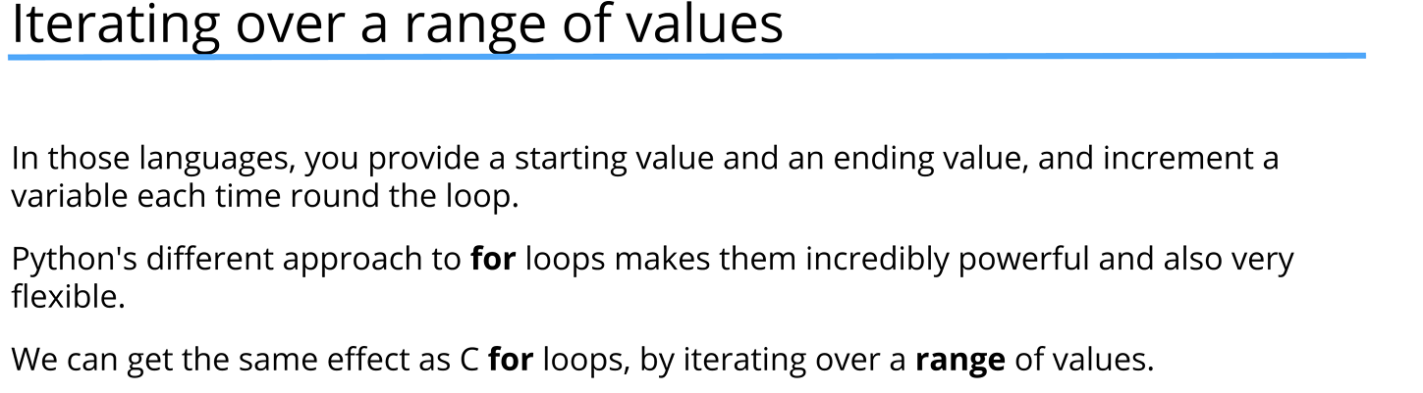
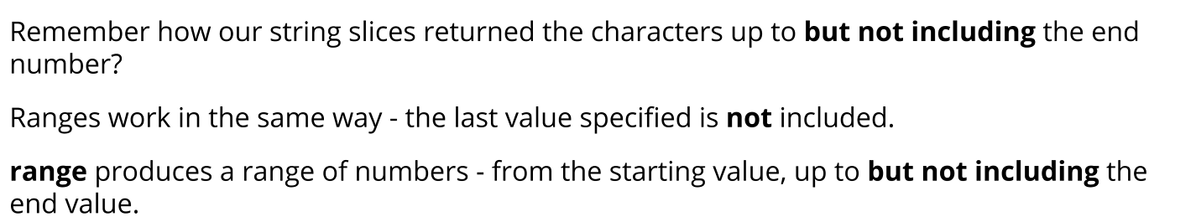
#range object can be used in for loops to generate a sequence of numbers
# The range() function can take one, two, or three arguments:
# range(stop) - generates numbers from 0 to stop-1
# range(start, stop) - generates numbers from start to stop-1
# range(start, stop, step) - generates numbers from start to stop-1, incrementing by step
# if we want to use step their must start and stop values
# step can be positive or negative
# using a negative step will generate numbers in descending order
# normally i isn't appropriate variable name, but it is a convention for loop counters
# if nested loops we can use j, k, etc.
for i in range(1, 21):
print(i)

for i in range(0, 11, 2):
print(i)

for i in range(10, 0, -1):
print(i)

#we can also use range to check whether a number is in a specific range
#it is not the most efficient way, but it works
#but it is more readable than using comparison operators

number = 5

if number in range(1, 11):
print(f"{number} is in the range")

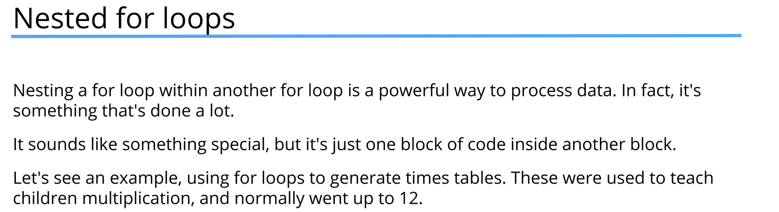
for i in range(1, 13):
for j in range(1, 13):
print("{0} times {1} is {2}".format(i, j, i * j))
print("-" * 20)

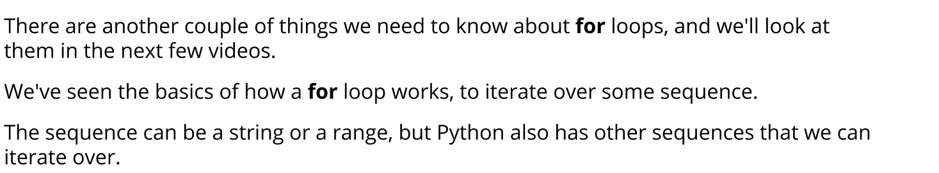
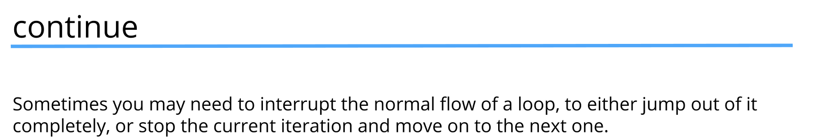
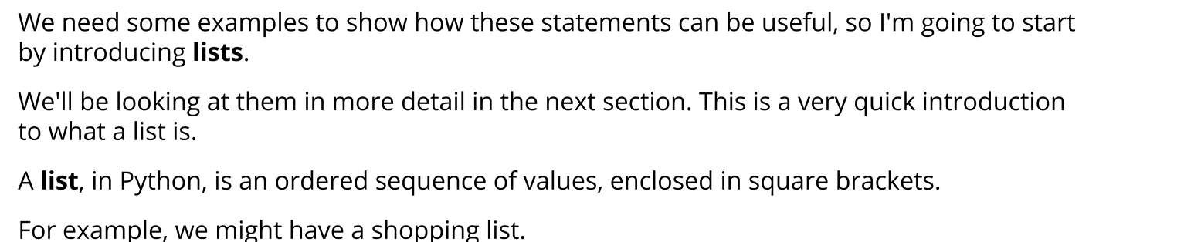
shopping_list = ["milk", "pasta", "eggs", "spam", "bread", "rice"]

# for item in shopping_list:
# if item != "spam":
# print("Buy " + item)

for item in shopping_list:
#continue prevents the rest of the code in the loop from executing
#it makes the loop jump to the next iteration
if item == "spam":
continue
print("Buy " + item)

shopping_list = ["milk", "pasta", "eggs", "spam", "bread", "rice"]

for item in shopping_list:

if item == "spam":
#break statement stops the loop entirely
break
print("Buy " + item)

shopping_list = ["milk", "pasta", "eggs", "spam", "bread", "rice"]

item_to_find = "spams"
# None is used to represent 'no value' or 'not found'
# It is a special value in Python that means "nothing"
found_at = None
#len function gives the length of a sequence like a list
shopping_list_length = len(shopping_list)

# Loop through the list by index
# it is combined with range function since the loop will start at 0
# and go up to (but not including) the length of the list
for i in range(shopping_list_length):
if shopping_list[i] == item_to_find:
found_at = i
# Exit the loop once the item is found
# So we don't waste time continuing the
# loop after we've found the item
# it helps with efficiency
break

# In Python, the is operator is used to check object identity, not value equality.

# What that means

# is checks whether two variables refer to the exact same object in memory.

# It does not compare the contents or values of the objects.

# Syntax
# a is b

# Example
# x = [1, 2, 3]
# y = x
# z = [1, 2, 3]

# print(x is y) # True → same object
# print(x is z) # False → different objects, same values

# is vs ==
# Operator Purpose
# is Checks identity (same object in memory)
# == Checks equality (same value/content)
# print(x == z) # True (values are equal)
# print(x is z) # False (different objects)

# Common and correct use cases

# ✅ Checking against None

# if value is None:
# print("No value provided")

# ✅ Singleton objects (True, False, None)

# a = None
# b = None
# print(a is b) # True
# if found_at is not None:

if found_at:
print(f"{item_to_find} is at index {found_at}")
else:
print(f"{item_to_find} is not found!")

